- There was a modest upside surprise for UK CPI inflation in March, following smaller-than-expected declines in food and services prices. But we still expect inflation to fall rapidly in April due to the 12% cut in the energy price cap and our expectation that once-a year rises in inflation-linked contracts and regulated prices will be much smaller than last year.
- But the recent uptick in oil and gas futures prices mean we now think these categories will weigh slightly less heavily on headline inflation this year. So we now forecast CPI inflation will average 2.3% in 2024, up from 2.1% last month.
CPI inflation fell to 3.2% in March from 3.4% in February. March's decline was due to base effects in the food and core categories, after unusually large rises in these components between February and March last year. This downward pressure was only partly offset by higher petrol prices. Inflation was slightly higher than we had expected in March due to sticky services inflation; the early Easter may have had a part to play in this. RPI and RPIX inflation both edged down by 0.2ppts to 4.3% and 3.3% respectively.
The downward pressure on inflation is set to continue in the coming months. April's 12% drop in Ofgem's energy price cap will increase the drag from the energy category. In the same month, the annual uprating in many inflation-linked contracts or regulated prices should be smaller than last year, which will weigh on core inflation. Meanwhile, the ongoing impact of base effects on food prices will mean the positive contributions from this category should fade further in the coming months. Therefore, headline inflation is likely to return to the 2% target in Q2 and then fall below this mark for much of H2 2024. Still, our forecast that inflation will average 2.3% this year, is 0.2ppts higher than in our March update, reflecting the recent rises in oil and gas futures prices.
There is a high degree of uncertainty surrounding the April outturn. In addition to the impact of the earlier-than-usual Easter, which could unwind in April's data, the scale of the rises for index-linked contracts and regulated prices is particularly uncertain. Given these are annual price changes, April's outturns for these categories will have a major impact on the inflation outlook for the rest of the year.
Chart 1: Higher oil and gas futures prices have raised our 2024 inflation forecast to 2.3%
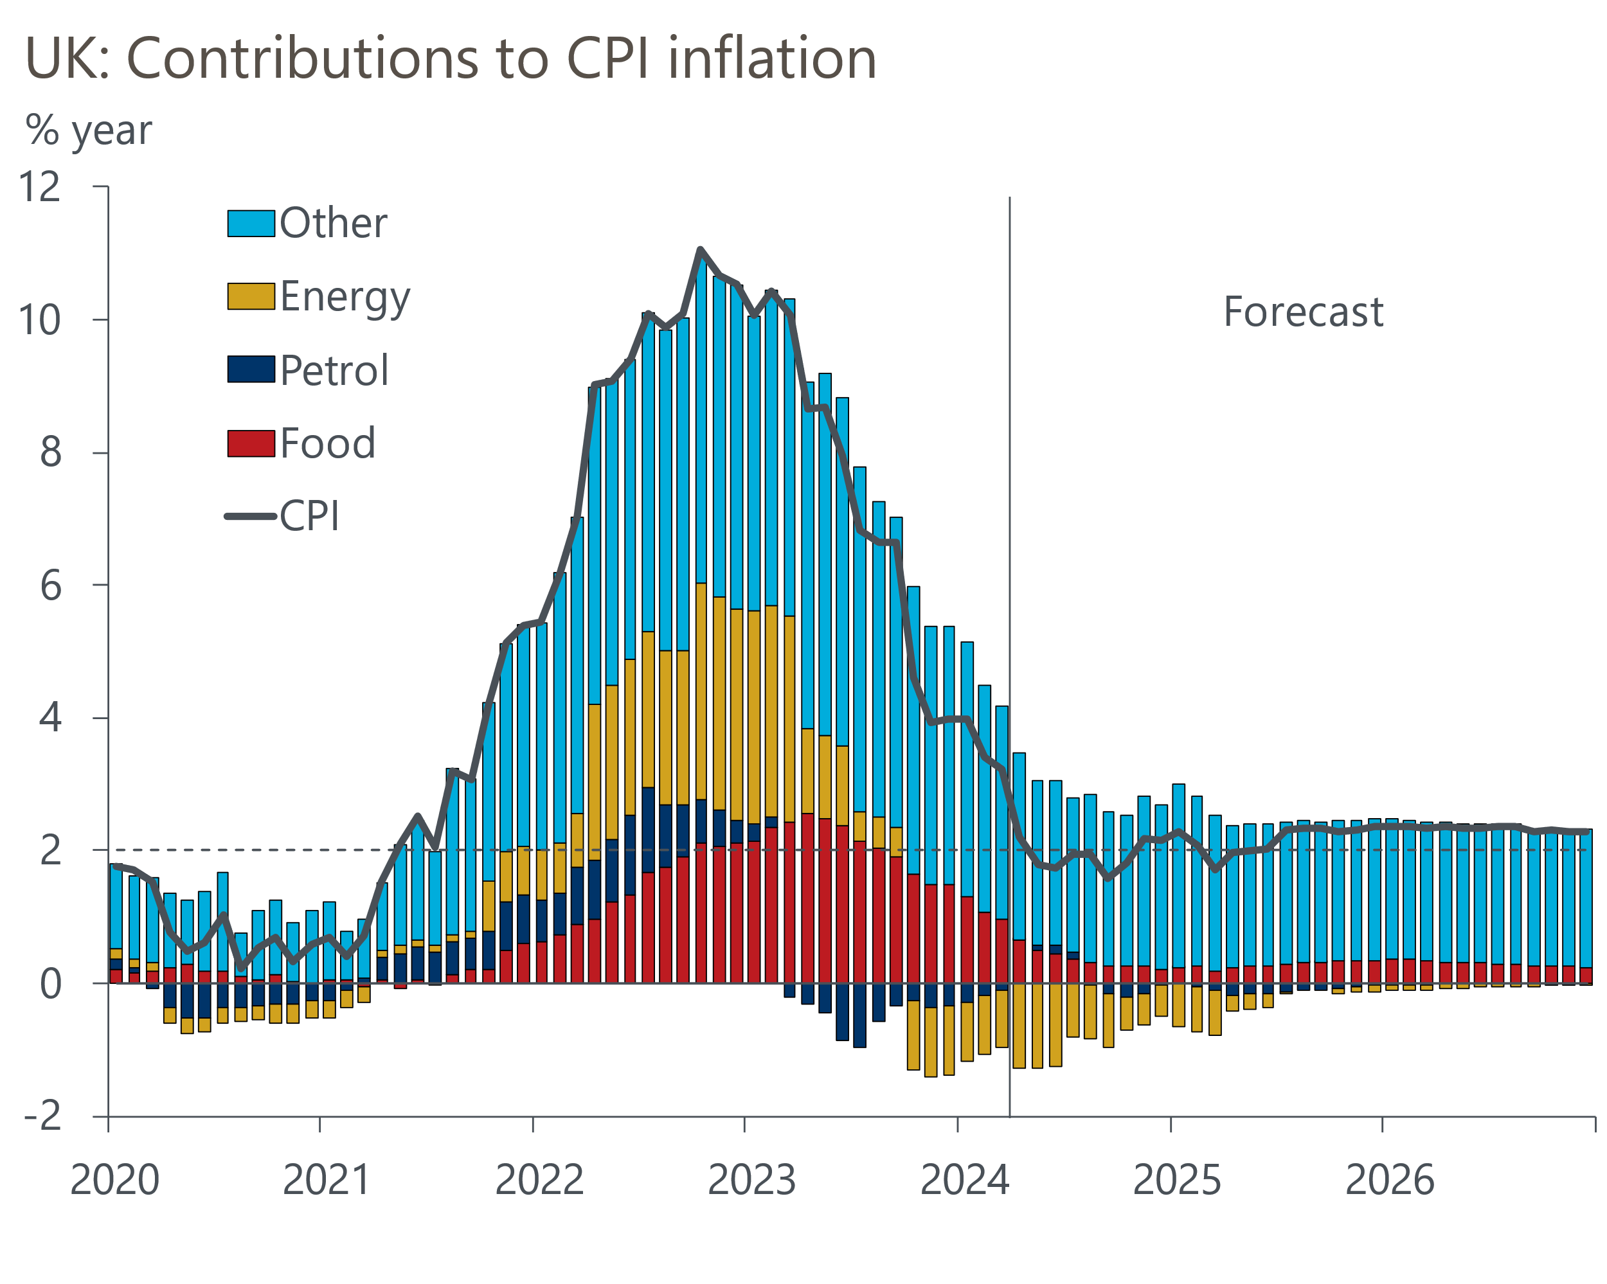
Source: Oxford Economics, Haver Analytics

